Canadian Museum of Nature

Article: Canadian Museum of Nature
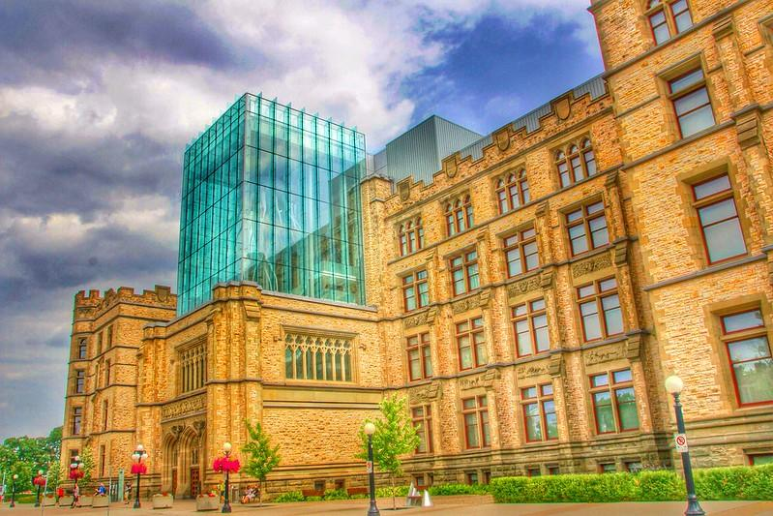
Photo by Bill Badzo

One of Ottawa’s most notable buildings can be found downtown, just two kilometres from Parliament Hill. It looks like a castle, but there are no knights or royalty here - it’s the Canadian Museum of Nature. The Museum was Canada’s first national museum, now one of nine.

The first thing visitors see when they enter the museum is a giant, floating planet Earth in the atrium. It is half of an art installation by British artist Luke Jerram, named Gaia. It shows the planet in incredible detail, using imagery of the Earth’s surface as an astronaut would see it. It is accompanied by Moon, a similar sculpture of the moon.

The Museum has 18,910 square metres of gallery space. The galleries begin on the first floor with the very popular Fossil Gallery, where visitors can see real and replica fossils of dinosaurs, flying and marine reptiles and prehistoric mammals. There are over 30 complete skeletons on display. There are many more mammals in the Mammal Gallery, where incredible dioramas show scenes of Canadian wildlife from across the country.

Across from the Mammal Gallery on the second floor is another gallery very popular with young visitors, the Water Gallery. The star of the gallery is a massive blue whale skeleton, one of only two on display in Canada. There are interactive water tanks with real animals including turtles, jellyfish and sea urchins that visitors can touch and learn about from science interpreters. The Gallery also aims to educate about climate change, with information on increasing threats to plants and animals that live in water like pollution and plastic waste.

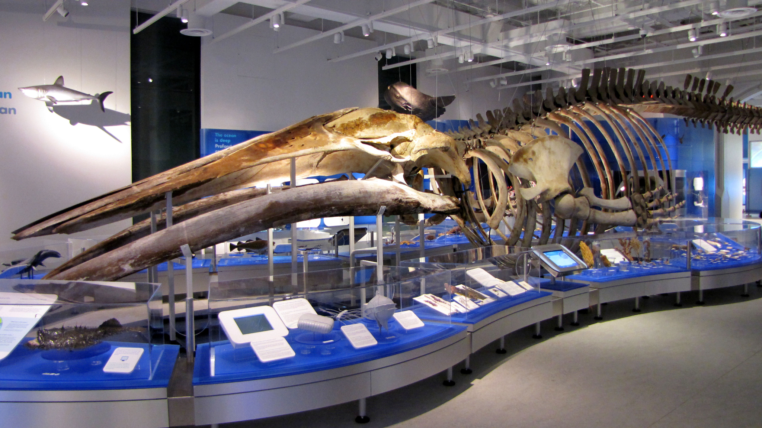
Photo by D. Gordon E. Robertson

The third floor of the Museum is home to the Earth Gallery, which showcases the geology of Canada with rocks and mineral specimens. It has a limestone cave that visitors can walk through, and a meteorite that is older than Earth. In the Bird Gallery there are over 500 species of birds on display - the largest collection of Canadian birds in the world.

Finally, the top floor hosts the Arctic Gallery, which showcases a very unique region of the planet. Roughly 40% of Canada’s land is arctic climate, and this intriguing ecosystem is shown in full colour.

The fascinating features are not only inside the building, however. The Museum of Nature’s architecture is also worth viewing from outside. The castle-like building is a mix of several architectural styles including Tudor, Beaux-Arts and Neo-Gothic. It was the first building in Canada to be decorated with Canadian plants and animals in the design. Also outside is the Landscapes of Canada Gardens, which feature seasonal plants from across the country. It has over 60 species of native plants, with information on them on plaques and benches. There are also three statues of Woolly Mammoths, which are popular for taking photos.

Questions
What special distinction does the Canadian Museum of Nature have?

What is Gaia?

What are some of the features of the Water Gallery?

What is outside of the museum?

Activity: By the Numbers
What do the following numbers from the article represent?

Number | What it is
9 | National Museums of Canada currently
2 kilometres
18,910 square metres
500
30

Video: Highlights of Canada’s First National Museum: A Guided Virtual Tour
(https://www.youtube.com/watch?v=iFUxqANx2v8, Canadian Museum of Nature on YouTube)

The tour guide compares the first dinosaur skeleton (a Daspletosaurus) in the Fossil Gallery to a Tyrannosaurus rex, and says it is like T. rex’s ‘little cousin’. How do they compare?

What does the guide call ‘a lost art’ and ‘a blend of art and science’?

The Arctic Gallery represents a new way the museum displays nature. What is different about it?

What is your favourite item or place shown in the video?

Article: History and Buildings - Canadian Museum of Nature
(https://nature.ca/en/about-the-museum/history-buildings/, Canadian Museum of Nature)

True or false?
The Canadian Museum of Nature was once called the Victoria Memorial Museum Building. True / False

The design of the building was meant to mirror the Parliament buildings. True / False

The land where the museum is was once a cow pasture. True / False

The Queens’ Lantern addition was named in honour of Queen Elizabeth II and her grandmother Queen Mary. True / False

Multiple choice
The dinosaur called Edmontosaurus regalis is special because:
- It was discovered near the museum in Ottawa
- It was the first dinosaur to be displayed in Canada
- It was the first item purchased by the Canadian Museum of Nature

Why did the museum building start sinking after construction?
- The stones used to build the walls were unstable
- The soil underneath it is too wet and muddy to support its weight
- The ground underneath is too unstable to support its weight

Why did the Victoria Memorial Museum Building become home to Parliament in 1912?
- Parliament Hill was still under construction
- Centre Block was destroyed by a disaster
- There were too many people to fit in Centre Block

