Forge FC
Forge FC (Forge Football Club) is a professional soccer team located in Hamilton, Ontario.

Article: Forge FC unveiled as Hamilton’s Canadian Premier League club
(https://forgefc.canpl.ca/article/forge-fc-unveiled-as-hamiltons-canadian-premier-league-club, Forge FC)

When was the Forge FC announced?

What does its name represent?

What league does the team play in?

The article announces the imagery and symbolism of the team’s crest and colours. What do they represent?

Colours:
Spark Orange | Platinum Steel | Waterfall White

Crest:
Element | Symbolism
Letter ‘H’ monogram
Waterfall inside the ‘H’
Three sparks at the top
Letter ‘F’ between the sparks

What is the team’s secondary crest?

Video: Forever First: The Story of Forge FC’s Inaugural Championship - Part One
(https://www.youtube.com/watch?v=UJRG5kzYj7o, Forge FC on YouTube)

What do the Forge players say their Coach tells them in the beginning of the video?

Who were the favourites to win before the first Canadian Premier League championship?

What did the talk show panellists say was a concern for Forge prior to the championships?
- Their captain being injured
- Defensive absences
- Poor goaltending

What kind of flags do the team’s supporters wave at games?

What penalty did the Cavalry player Joel Waterman receive a red card for during the first game of the finals?
- Handball
- Offensive language
- Violent conduct

Who scored the only goal of the first game?

Video: Forever First: The Story of Forge FC’s Inaugural Championship - Part Two
(https://www.youtube.com/watch?v=V7MQ7h3vZ3Y&ab_channel=ForgeFC, Forge FC on YouTube)

What is the team doing in the beginning of the video?

What does the coach stress to them during the warm-ups before the match?
- Team cooperation
- Concentration on the ball
- Avoiding penalties

What day is the final match?

What are the team’s away jersey colours?

What was the score after the first half of the game?

What do the commentators mean by ‘forever first’?

What does the trophy look like?

Article: Forge FC wants to ‘win everything’
(https://www.thespec.com/sports/soccer/opinion/2023/04/13/forge-fc-wants-to-win-everything.html, Steve Milton for the Hamilton Spectator)

How many championships has the team won since 2019?

What is their other goal besides another CPL championship?

By the numbers
What do the following numbers from the article represent?
Number | Meaning
18
60%
5,000-6,000
Six
18

Vocabulary words
Match each term from the articles with its definition:
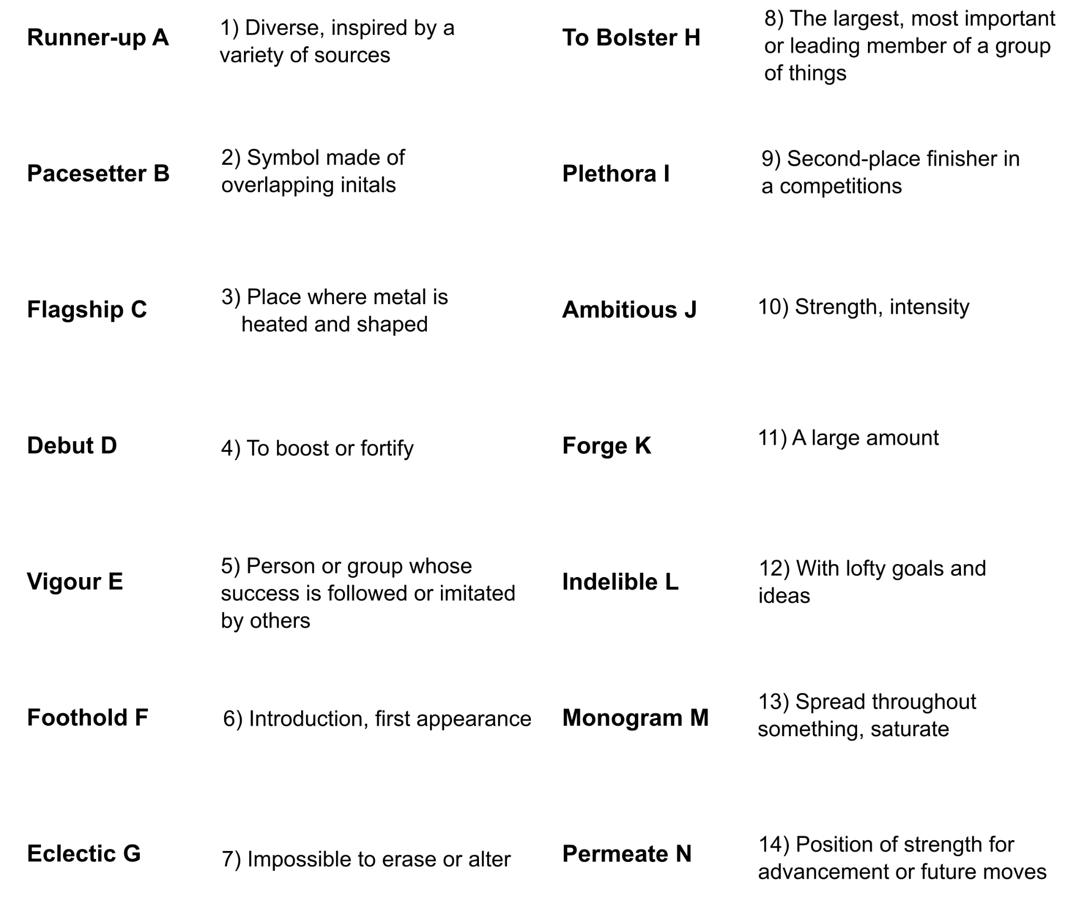

A -
B -
C -
D -
E -
F -
G -

H -
I -
J -
K -
L -
M -
N -

