Forge FC
Forge FC (Forge Football Club) is a professional soccer team located in Hamilton, Ontario.

Article: Forge FC unveiled as Hamilton’s Canadian Premier League club
(https://forgefc.canpl.ca/article/forge-fc-unveiled-as-hamiltons-canadian-premier-league-club, Forge FC)

When was the Forge FC announced?
-July 12 2018

What does its name represent?
-the industrial history of the city of Hamilton: a forge is a workshop where metal is heated and shaped, and Hamilton is a steel manufacturing hub
-ambitious goals to advance: in the sense of metaphorically ‘forging’ a bold path

What league does the team play in?
-Canadian Premier League (CPL), a new men’s professional league that began play in 2019

The article announces the imagery and symbolism of the team’s crest and colours. What do they represent?

Colours:
Spark Orange | Platinum Steel | Waterfall White
-the sparks from a striking hammer  -the energy of the city of Hamilton  -the orange colours of brick houses, sunrises and sunsets | -the history of Hamilton’s steel mills | -the waterfalls in the Hamilton area  -there are over 100 waterfalls between the Bruce Trail and the Niagara Escarpment

Crest:
Element | Symbolism
Letter ‘H’ monogram | -short for the city’s name
Waterfall inside the ‘H’ | -the 100 waterfalls in the Hamilton area
Three sparks at the top | -the city, club and community the team is founded on
Letter ‘F’ between the sparks | -the energy of the team

What is the team’s secondary crest?
-a hammer, which recall’s Hamilton’s nickname ‘The Hammer’

Video: Forever First: The Story of Forge FC’s Inaugural Championship - Part One
(https://www.youtube.com/watch?v=UJRG5kzYj7o, Forge FC on YouTube)

What do the Forge players say their Coach tells them in the beginning of the video?
-he believes in them and preaches that they should believe in themselves

Who were the favourites to win before the first Canadian Premier League championship?
-Cavalry FC, the Calgary team, also called ‘Cavs’

What did the talk show panellists say was a concern for Forge prior to the championships?
- Their captain being injured
- Defensive absences -several defensive players were out on suspensions
- Poor goaltending

What kind of flags do the team’s supporters wave at games?
-orange crest flags and orange and yellow checkered flags

What penalty did the Cavalry player Joel Waterman receive a red card for during the first game of the finals?
- Handball
- Offensive language
- Violent conduct

Who scored the only goal of the first game?
-Tristan Borges

Video: Forever First: The Story of Forge FC’s Inaugural Championship - Part Two
(https://www.youtube.com/watch?v=V7MQ7h3vZ3Y&ab_channel=ForgeFC, Forge FC on YouTube)

What is the team doing in the beginning of the video?
-travelling by bus and plane, retrieving luggage, arriving at a hotel
-they are travelling to Calgary for the second ‘leg’ or game of the championship finals

What does the coach stress to them during the warm-ups before the match?
- Team cooperation
- Concentration on the ball
- Avoiding penalties

What day is the final match?
-November 2 2019

What are the team’s away jersey colours?
-grey with orange trim and white lettering
-Tristan Henry, the goalie, wore all green

What was the score after the first half of the game?
-0-0, no score

What do the commentators mean by ‘forever first’?
-it means the team that won the championship (Forge) will forever be the first champions in the Canadian Premier League and make history

What does the trophy look like?
-a clear glass circle medallion with a maple leaf

Article: Forge FC wants to ‘win everything’
(https://www.thespec.com/sports/soccer/opinion/2023/04/13/forge-fc-wants-to-win-everything.html, Steve Milton for the Hamilton Spectator)

How many championships has the team won since 2019?
-three

What is their other goal besides another CPL championship?
-to compete in more international matches such as the Concacaf Champions League which includes clubs from North and Central America and the Caribbean

By the numbers
What do the following numbers from the article represent?
Number | Meaning
18 | International matches played by Forge FC
60% | Forge’s win rate in the CPL
5,000-6,000 | Expected spectators at each Forge game
Six | How many Forge players have played 100 CPL games
18 | How many players from the previous year’s team returned for the 2023 season

Vocabulary words
Match each term from the articles with its definition:
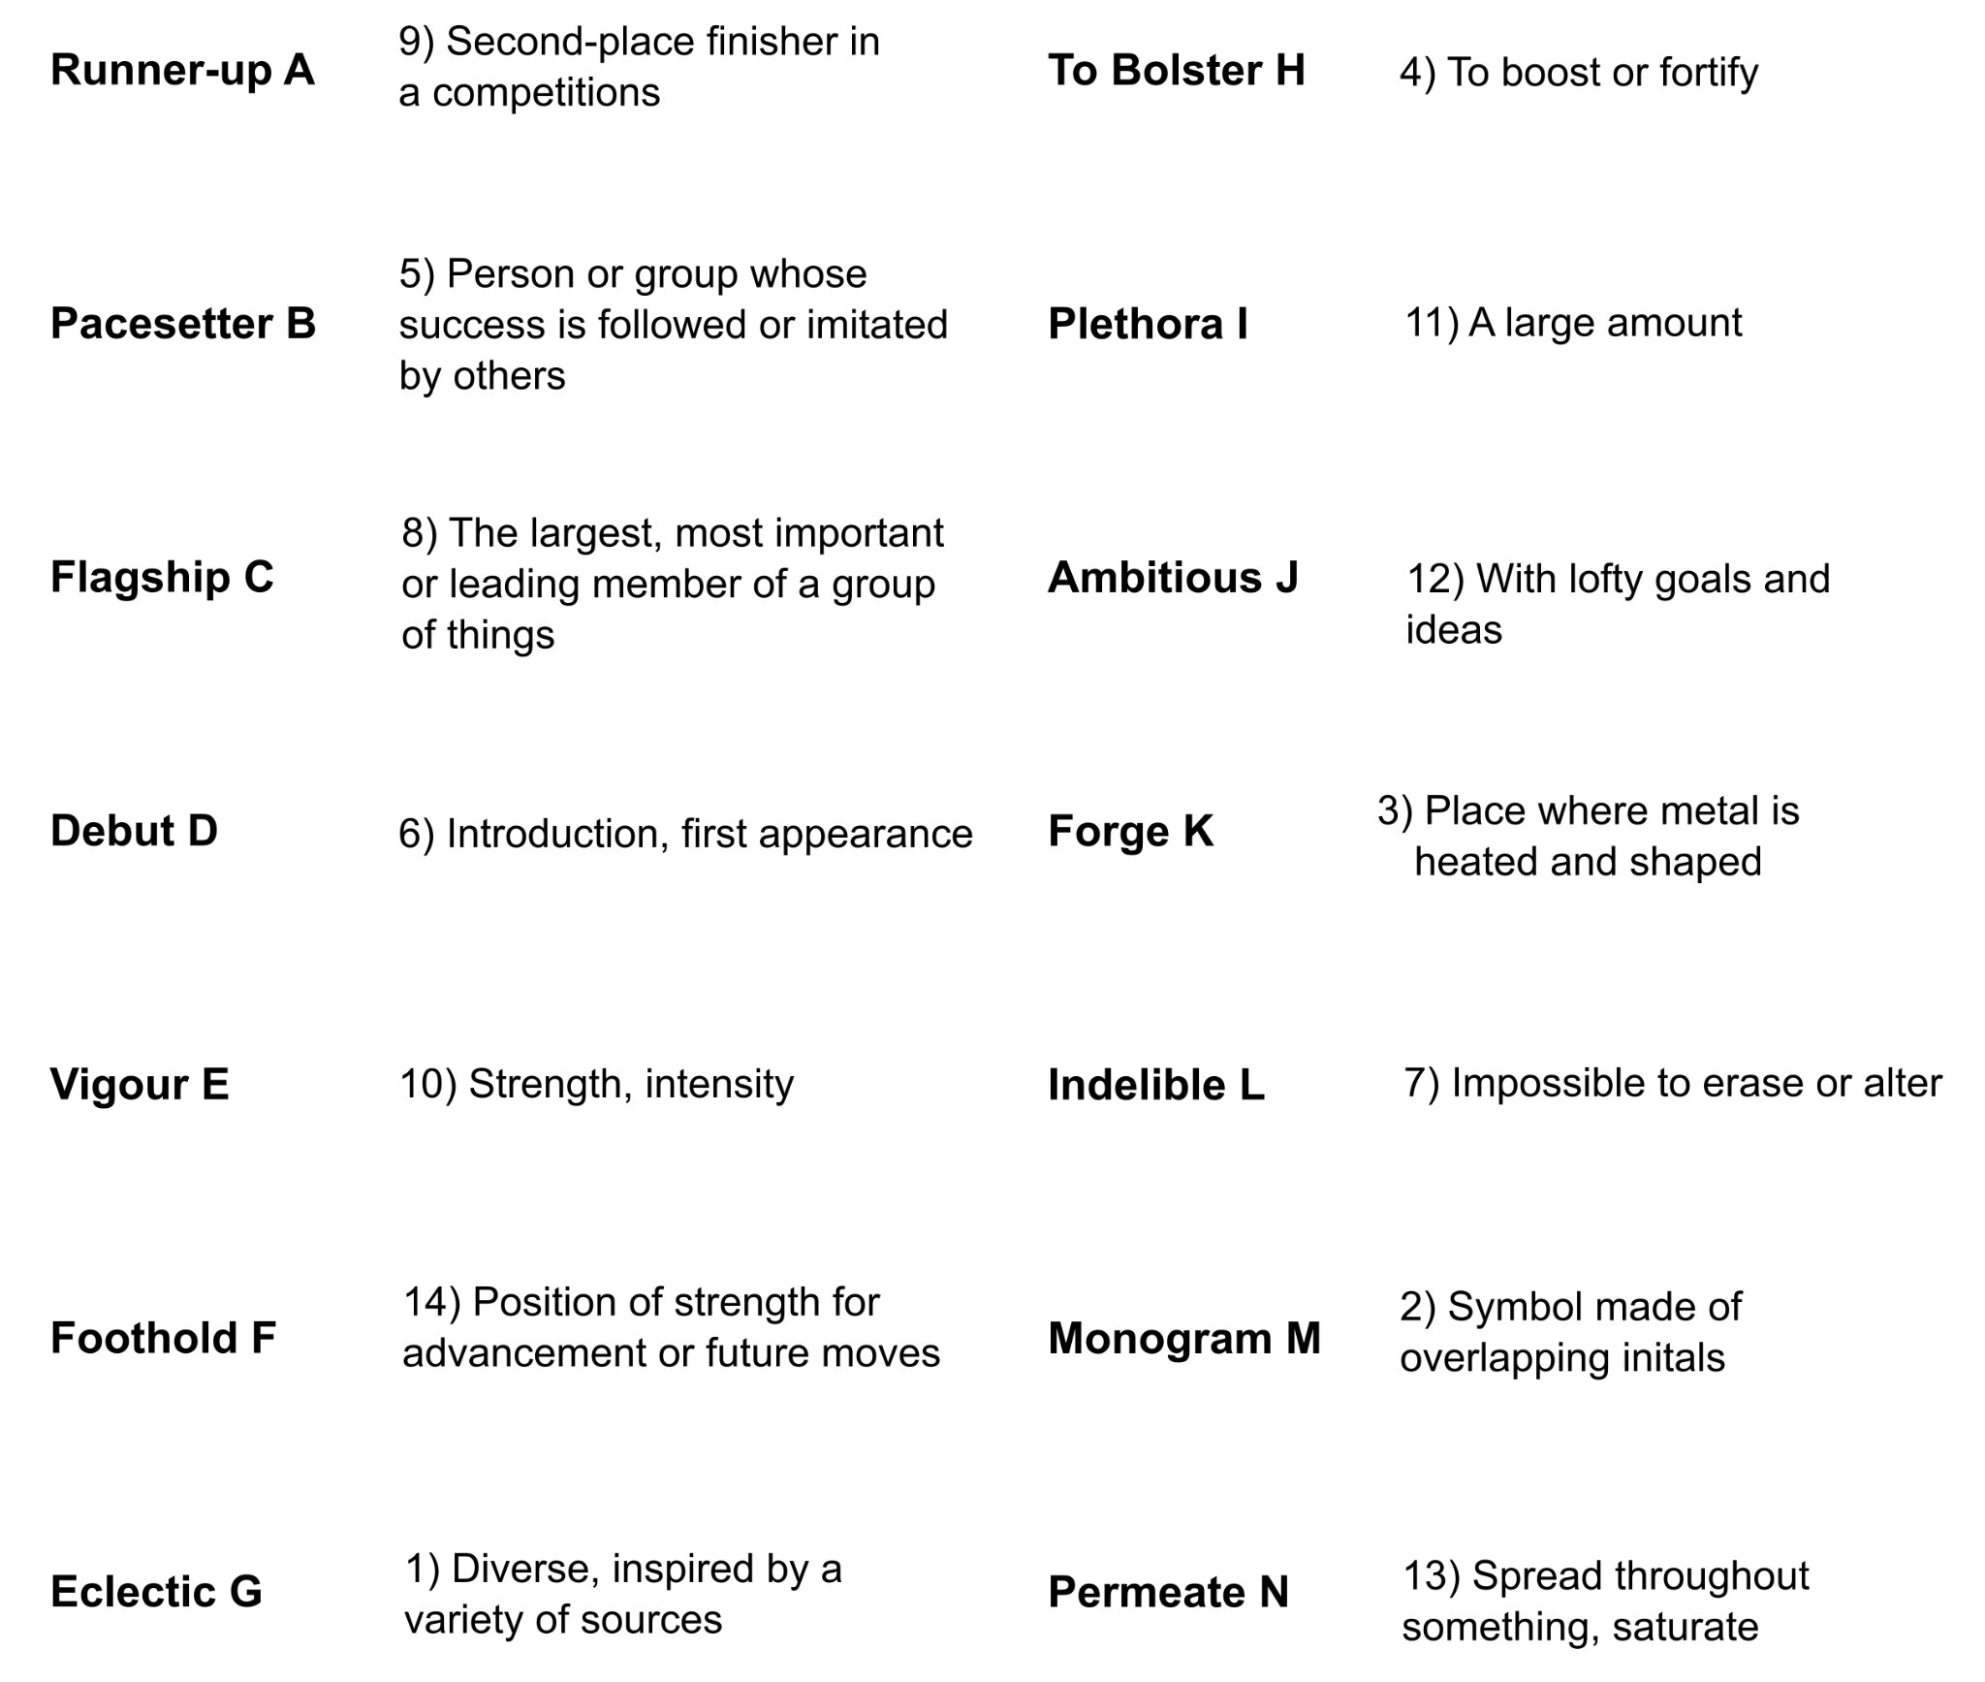

A - 9
B - 5
C -8
D - 6
E - 10
F - 14
G - 1

H -4
I - 11
J - 12
K - 3
L - 7
M - 2
N - 13

