Easter
Article: Easter in Canada
(https://www.thecanadianencyclopedia.ca/en/article/easter-in-canada Laura Neilson Bonikowsky, The Canadian Encyclopedia)

Who celebrates Easter?
-Christians
-although it is celebrated as a secular holiday by many others as well

When is Easter observed?
-the first Sunday after the first full moon after the spring equinox
-between March 22 and April 25

What is Mid-Lent?
-a holiday marking the halfway point of Lent, the 40 day period before Easter
-it is a French holiday that is still celebrated in some French-Canadian communities in Quebec and the Maritime provinces

What is the origin of the name Easter?
-it is probably derived from the name of an Anglo-Saxon mother goddess named Eastre or Eostre
-she was associated with spring and new life, as is the Easter celebration

What do the gods Horus, Ishtar, Dionysus and Mithras have in common?
-they all have stories/mythology involving death and resurrection

Which two meats are commonly served at Easter?
-lamb and ham
-lamb symbolises Jesus Christ, the ‘Lamb of God’
-ham was used in pre-Christian pagan spring celebrations and was believed to be lucky

Article: Eastern Symbols and Traditions
(https://www.history.com/topics/holidays/easter-symbols History.com editors)

How did the Easter Bunny myth begin?
-it began in Germany as a hare that laid eggs
-German immigrants to the United States of America brought the legend with them in the 1700s

Do eggs have religious meaning to Christians?
-originally no, they likely became associated with Easter as they were forbidden during the Lent period prior to it
-however some people consider egg-rolling to convey religious imagery

Which flower is most associated with Easter?
-white lilies
-their growth from a dormant bulb is used to symbolise rebirth and resurrection

True or false
Are the following statements about Easter true or false?

Easter is a statutory holiday in Canada. True

Mid-Lent is an English holiday celebrated in some Canadian communities. False - it is a French holiday

Hot cross buns are rectangular with crosses carved into them. False - they are circular with crosses made of icing

German children originally made nests for the Easter Bunny to lay eggs in. True

Jelly beans are the top-selling non-chocolate Easter candy in the United States. False - the top-selling non-chocolate confection is Peeps, bunny- and chick-shaped marshmallows

Lilies are native to Japan. True

Egg idioms
Match the idioms on the left to their literal meanings on the right

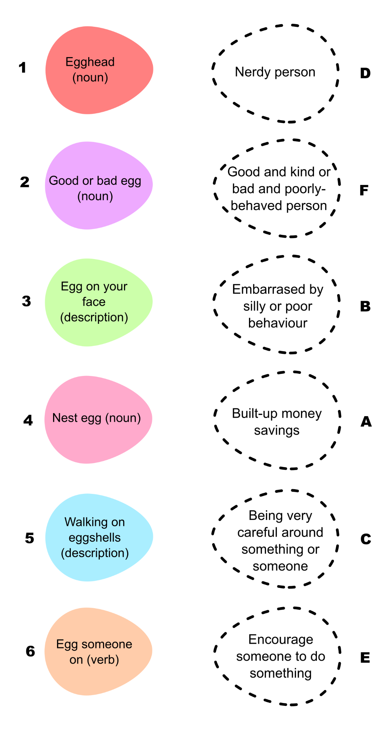

Answers:

1 - D

2 - F

3 - B

4 - A

5 - C

6 - E

