Easter
Article: Easter in Canada
(https://www.thecanadianencyclopedia.ca/en/article/easter-in-canada Laura Neilson Bonikowsky, The Canadian Encyclopedia)

Who celebrates Easter?

When is Easter observed?

What is Mid-Lent?

What is the origin of the name Easter?

What do the gods Horus, Ishtar, Dionysus and Mithras have in common?

Which two meats are commonly served at Easter?

Article: Eastern Symbols and Traditions
(https://www.history.com/topics/holidays/easter-symbols History.com editors)

How did the Easter Bunny myth begin?

Do eggs have religious meaning to Christians?

Which flower is most associated with Easter?

True or false
Are the following statements about Easter true or false?

Easter is a statutory holiday in Canada.

Mid-Lent is an English holiday celebrated in some Canadian communities.

Hot cross buns are rectangular with crosses carved into them.

German children originally made nests for the Easter Bunny to lay eggs in.

Jelly beans are the top-selling non-chocolate Easter candy in the United States.

Lilies are native to Japan.
Egg idioms
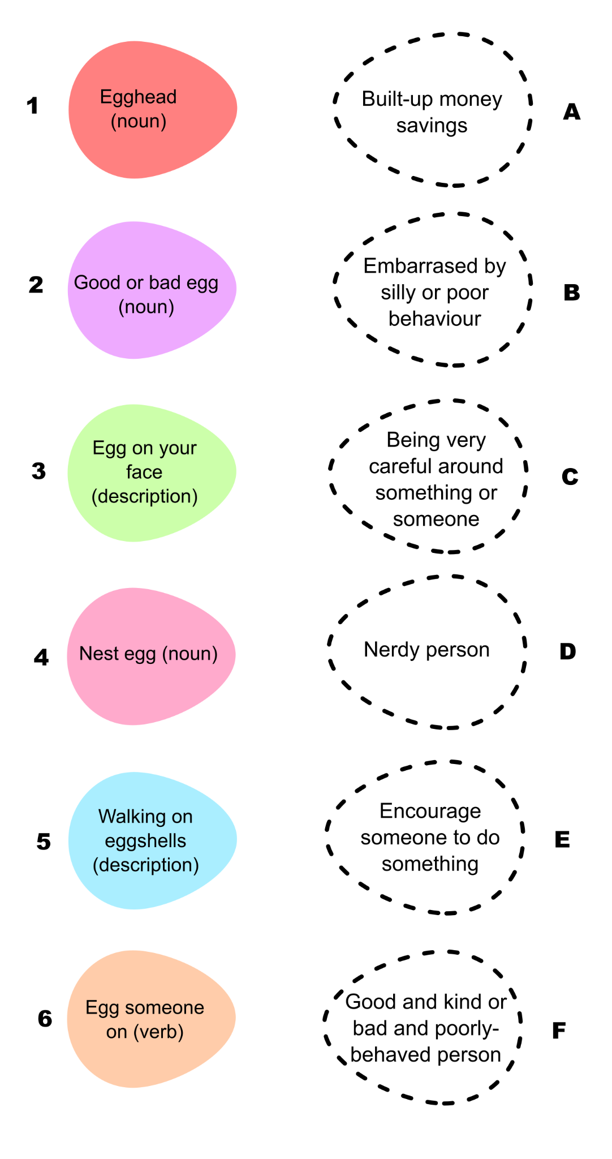
Match the idioms on the left to their literal meanings on the right

Answers:

1 -

2 -

3 -

4 -

5 -

6 -

